**Legendary Locations**

Due to restrictions with Gen IV hacking, the following Legendaries are found in random areas with low encounter rates;

**Rotom**

**Old Chateu**

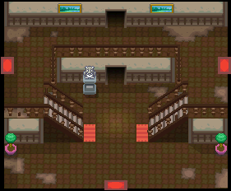



Rotom can also be found roaming the Old Chateau

**Level 15**

**Raikou**

**Fuego Ironworks**

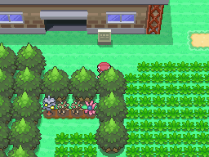

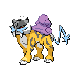

Raikou can be found at the Fuego Ironworks

**Level 30**

**Entei**

**Mt. Coronet**

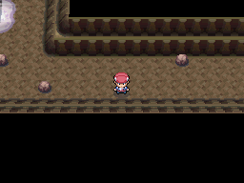

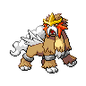

Entei can be found at the top of Mt. Coronet

**Level 30**

**Suicune**

**Snowpoint Temple**

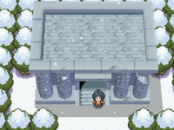



Suicune can be found in the first room of Snowpoint Temple

**Level 30**

**Registeel**

**Iron Island**

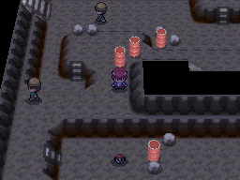



Registeel can be found at Iron Island (B2F – Right Cave)

**Level 40**

**Regice**

**Mt. Coronet – Snowy Area**

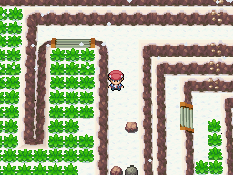

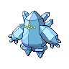

Regice can be found in the snowy area of Mt. Coronet

**Level 40**

**Regirock**

**Victory Road**

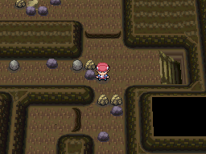

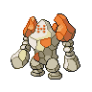

Regirock can be found at the entrance of Victory Road

**Level 40**

**Regigigas**

**Snowpoint Temple**

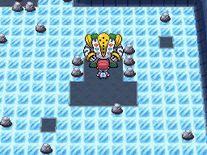



Regigigas can be found in the basement of Snowpoint Temple

**Level 01**

**Celebi**

**Lake Verity**

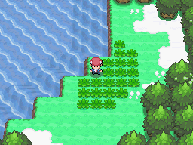



Celebi can be found later on at Lake Verity

**Level 10**

**Shaymin**

**Great Marsh**

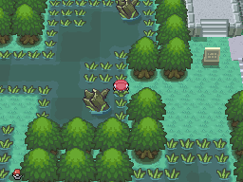



Shaymin can be found at The Great Marsh

**Level 30**

**Ho-Oh**

**Stark Mountain**

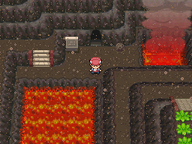



Ho-Oh can be found at the Peak of Stark Mountain

**Level 70**

**Lugia**

**Route 230**

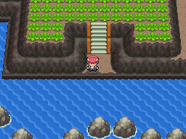

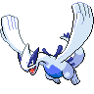

Lugia can be found in the waters of Route 230

**Level 70**

**Groudon**

**Route 226**

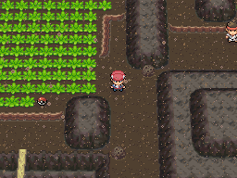

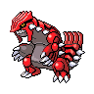

Groudon can be found on Route 226

**Level 70**

**Kyogre**

**Route 226**

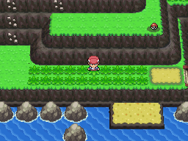

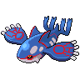

Kyogre can be found in the waters of Route 226

**Level 70**

**Rayquaza**

**Route 225**

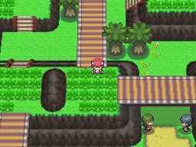

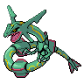

Rayquaza can be found on Route 225

**Level 75**

**Latios & Latias**

**Route 224**

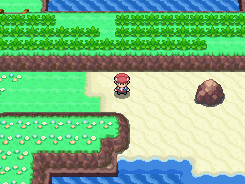

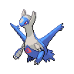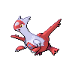

Latios & Latias can be found on Route 224

**Level 55**

**Mewtwo**

**Victory Road – National Dex Area**

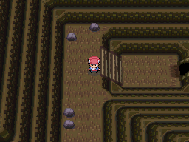



Mewtwo can be found in the latter area of Victory Road

**Level 70**

**Mew**

**Victory Road – National Dex Area**





Mew can be found in the latter area of Victory Road

Level 30

**Jirachi**

**Route 222**

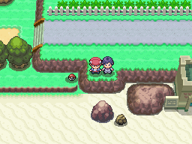



Jirachi can be found in the waters of Route 222

**Level 45**

**Deoxys**

**Ruin Maniac Cave**

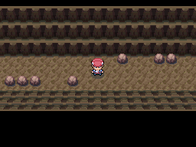



Deoxys can be found at Maniac Tunnel which is accessed after obtaining all Unown

**Level 30**

**Manaphy**

**Resort Area**

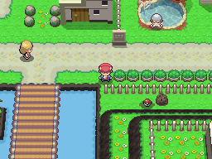



Manaphy can be found in the waters of The Resort Area

**Level 50**

**Phione**

**Resort Area**





Phione can be found in the waters of The Resort Area

**Level 35**

**Darkrai**

**Iron Island**

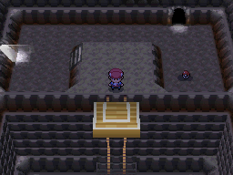



Darkrai can be found on the lowest floor at Iron Island

**Level 40**

**Arceus**

**Route 228**

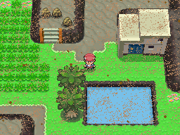



Arceus can be found at Route 228 with a considerably low encounter rate

**Level 80**

With the limitations of hacking in Pokémon Platinum, it’s not too easy to create new overworlds, insert them, find appropriate sprites and set up a fully function script without the possibility of something going wrong. Although the methods of finding legendaries may seem a little simple, they are still rather difficult to find